**CHAPTER 1**

1. **INTRODUCTION**

Face is one of the most important means of human communication. Human Beings have the natural ability to look at someone’s face and guess their mood. This ability if learnt by an electronic device can have valuable applications in the real world. Music, a tool for arousing emotions and feelings, is far more powerful than language. Music is something which taps deeply into our emotional core as human beings. Thus, listening to good music can help us elevate our mood. It plays a central role in all social interactions. Facial expressions are non-verbal clues to emotions. Indeed, some facial muscles are specifically associated with certain emotional states and allow, according to Ekman the expression of primary emotions (Sad, Anger, Fear, Joy, Disgust and Surprise).

A technology called facial emotion recognition is used to evaluate emotions in various media, including photos and videos. It is a member of the group of technologies known as "affective computing," which is a multidisciplinary field of study on how well computers can understand and recognize affective states and human emotions. Affective computing frequently builds on Artificial Intelligence technologies.

The examination of facial landmark positions, such as the end of the nose and the brows, forms the basis for emotion recognition. Additionally, in videos, changes in those positions are also examined in order to spot facial muscle contractions. Faces can indicate fundamental emotions (such as anger, disgust, fear, joy, sadness, and surprise) or compound emotions (such as happily sad, happily surprised, happily disgusted, tragically afraid, sadly angry, sadly surprised), depending on the algorithm.

Artificial neurons that receive and analyze incoming data make up a neural network. In fig(1.1) The input layer, the hidden layer, and the output layer all receive data.

When input data is provided to a neural network, it begins to function. The intended result is subsequently produced by processing the data through its layers.

A neural network generates results after learning from structured data. There are three types of learning that can occur within neural networks:

• Supervised Learning: Inputs and outputs are given to the algorithms using labelled data. After receiving training on how to evaluate data, they then anticipate the intended outcome.

• Unsupervised Learning - Without human supervision, ANNs learn. The output is decided based on patterns found in the output data; there is no labelled data.

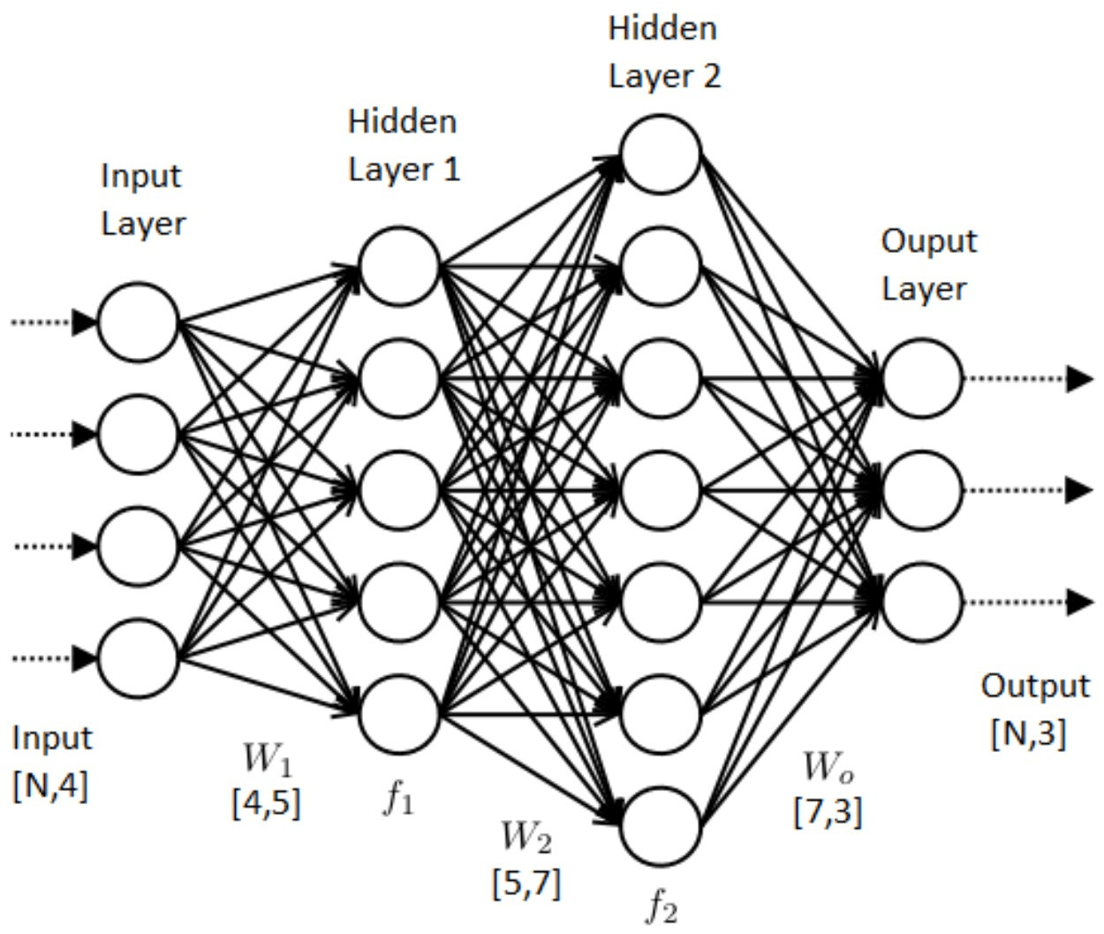• Reinforcement learning: Based on the feedback you provide, the network adapts.

Fig 1.1. Process of Neural Network

**1.1 OBJECTIVE**

The objective of the facial emotion recognition and music suggestion system is to provide a personalized and engaging music listening experience to users based on their current emotional state. The system aims to:

1. Detect the user's facial emotions in real-time using computer vision and machine learning techniques.

2. Recommend music that matches the user's emotional state based on a pre-defined mapping of emotions to music genres or songs.

3. Provide an intuitive and user-friendly interface that allows users to interact with the system easily.

4. Enhance the user's emotional state through the power of music and improve their overall well-being.

5. Explore the potential of using the system for music therapy treatment by creating a mechanism that can aid music therapists in treating patients suffering from mental health issues.

In summary, the facial emotion recognition and music suggestion system aims to provide a personalized and engaging music listening experience to users based on their current emotional state. The system utilizes computer vision and machine learning techniques to detect the user's facial emotions and recommends music that matches their emotional state, providing a powerful tool for improving emotional well-being.

**1.2 DATA PRE-PROCESSING**

Facial Expression Recognition (FER) is a type of computer vision task that involves recognizing and classifying facial expressions in images or videos. One of the key steps in building an accurate FER model is data preprocessing. In this context, data preprocessing involves preparing the data for the model by performing a set of operations such as data cleaning, dimension fixing, and image augmentation.

Dimension fixing, also known as rescaling, is a technique used to ensure that all images in the dataset have the same dimensions or size. This is important because neural networks are typically designed to work with inputs of fixed dimensions. By rescaling images to a fixed size, we can ensure that our model will be able to handle all images in the dataset without any issues.

Image augmentation is another important data preprocessing technique used in FER. It involves generating new images by applying a set of transformations to the original images in the dataset. These transformations can include things like rotating the image, flipping it horizontally or vertically, shifting it horizontally or vertically, and changing its brightness or contrast. By generating new images in this way, we can increase the size of our dataset, which can help our model to learn more robust and generalizable features.

Overall, data preprocessing is an essential step in building an accurate and robust FER model. By performing dimension fixing and image augmentation, we can ensure that our model will be able to handle all images in the dataset and will be able to learn robust features that generalize well to new data.

**1.3 BACKGROUND AND MOTIVATION**

Facial emotion recognition and music recommendation systems are two distinct fields that have gained significant attention in recent years due to their potential to enhance user experiences and address various real-world challenges.

The human face is a rich source of emotional cues, with facial expressions playing a crucial role in conveying emotions and social interactions. Recognizing and understanding facial emotions has been a longstanding interest in fields such as psychology, neuroscience, and computer vision. Fig 1.2 refers Facial emotion recognition technology aims to automatically detect and classify facial expressions to infer the emotional states of individuals. This technology has found applications in diverse domains, including human-computer interaction, entertainment, mental health, marketing, and more.

Music, on the other hand, has a profound impact on human emotions, often evoking strong feelings and influencing mood. The selection of appropriate music based on the emotional context can significantly enhance the user's engagement, enjoyment, and overall experience. Music recommendation systems leverage machine learning algorithms and user preferences to suggest relevant songs or playlists based on various factors, such as genre, artist, and mood.

The integration of facial emotion recognition with music recommendation systems offers a compelling opportunity to create a more personalized and emotionally engaging user experience. By detecting and analyzing facial expressions, the system can determine the user's emotional state in real-time. This information can then be leveraged to recommend music that aligns with the user's current emotions, providing a tailored and immersive musical experience.

The motivation behind this project stems from the potential benefits it offers across multiple domains. In entertainment platforms, such as music streaming services or video sharing platforms, users can enjoy customized music playlists that cater to their emotional needs, resulting in enhanced satisfaction and prolonged engagement. In mental health applications, the project can contribute to mood regulation, stress reduction, and emotional support, providing individuals with a personalized therapeutic experience. Additionally, the integration of facial emotion recognition and music recommendation can have significant implications in marketing and advertising by delivering emotionally appealing content to targeted audiences, leading to improved customer engagement and higher conversion rates.

Overall, the project aims to harness the power of facial emotion recognition and music recommendation systems to create a more immersive, personalized, and emotionally resonant user experience. By combining these two fields, we can bridge the gap between human emotions and technology, paving the way for innovative applications and advancements in affective computing.

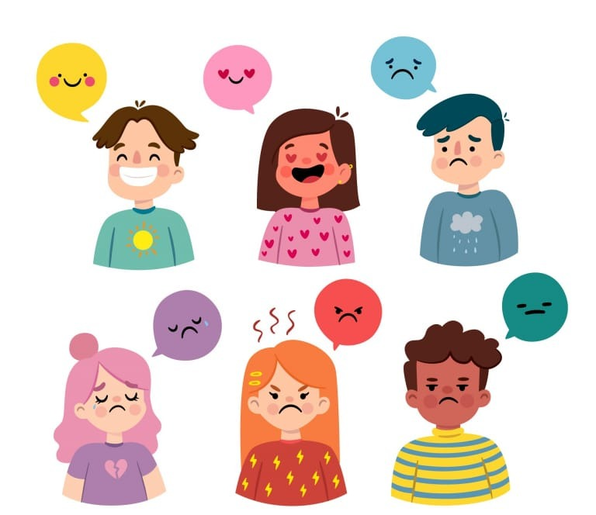

Fig 1.2 Types of Emotions

**1.4 CHALLENGES AND GAPS**

Facial Expression Variability: One challenge is the inherent variability in facial expressions across individuals and cultures. Developing a robust facial emotion recognition model that can accurately detect and classify emotions in diverse populations remains a challenge.

Subjectivity and Ambiguity of Emotions: Emotions can be subjective and ambiguous, making it difficult to precisely classify them based solely on facial expressions. Handling subtle or mixed emotions and addressing the inherent subjectivity of emotion recognition is a challenge.

Limited Training Data: Availability of annotated training data for facial emotion recognition models can be limited, especially for certain demographics or specific emotional states. Acquiring diverse and representative datasets poses a challenge in training accurate and unbiased models.

Generalization to Real-Life Scenarios: Facial emotion recognition models often perform well in controlled environments but struggle to generalize to real-life scenarios. Factors like lighting conditions, occlusions, and variations in camera quality can impact the model's performance.

Integration of Music Recommendation: Integrating the facial emotion recognition system with a music recommendation system requires addressing challenges such as mapping emotions to appropriate music genres or selecting suitable songs based on individual preferences.

User Acceptance and Adoption: Convincing users to adopt and trust facial emotion recognition technology can be a challenge, as concerns regarding privacy, data security, and potential misuse of emotional data may arise. Addressing these concerns and ensuring user acceptance is crucial.

**1.5 SUMMARY**

Overall, the project offers a range of benefits including personalized music experiences, improved user satisfaction, enhanced content creation, targeted marketing, and advancements in the field of affective computing, with potential societal impact in promoting emotional well-being.

**CHAPTER 2**

**2. LITERATURE SURVEY**

Proposed solution measures the reliability of the Facial Expression Recognition (FER) result. Based on the research we performed on the existing work present on the web related to reliability estimation for helping FER, we found that work performed in this direction is less, although there certainly exists related work that estimates the reliability of classification results. In the existing works, it has been shown that the classification performance can be further improved by exploiting the reliability estimation of the classification probability. As part of the solution that we implemented, the purpose is to improve the reliability of the classification performed by the model using deep CNN and transfer learning methodology, we have tried to improve the model performance such that the overall runtime involved in performing the classification is minimized so that the model can be easily integrated with the overall solution where the recommendation can also be performed using the classification given by the model.

# TITLE: RESEARCH ON FACIAL EXPRESSION RECOGNITION BASED ON NEURAL NETWORK

**YEAR OF PUBLISHING**: 2020

# AUTHOR NAME: Zhiheng Zhang

# ABSTRACT:

# For facial expression recognition, this paper proposes a cross-connected AlexNet improved convolutional neural network model. In general, due to lack of image information and noise interference, traditional machine learning methods lack robustness and poor recognition rate. Based on the advantages of deep learning in feature extraction, this paper adds a convolution layer and a pooling layer to the original AlexNet network structure, and uses the cross-connect method to extract low-level features from the network structure and combines advanced functions to construct a Classifier. The trainable features are used to extract feature convolution kernels, and then the pooling layer performs downsampling to eliminate unimportant information, reduce the amount of information calculation, and finally use the Softmax classifier for classification and recognition. Conduct comparative tests before and after the improvement to verify the performance improvement of the improved method.

# TITLE: DEEP LEARNING BASED FACIAL EXPRESSION RECOGNITION FOR PSYCHOLOGICAL HEALTH ANALYSIS

**YEAR OF PUBLISHING**: 2020

# AUTHOR NAME: C. Jonitta Meryl

# ABSTRACT:

# Facial Expression Recognition is known for its efficiency and its stimulating job in this automated world. Facial Expressions are the easiest way for human being to express their feelings. Facial expression plays a major role in communicating non-verbally. This paper summarizes the Facial Expression Recognition (FER) techniques based on deep learning. FER technique's performance is compared based on the amount of expressions recognized and the difficulty of algorithms in CNN. FER 2013 database is been used here. Recently, the CNN (Convolutional Neural Networks) has gained the reputation within the field of deep learning owing to their effective design and also the ability to produce smart results without manual feature extraction from the raw information. This paper investigates the effectiveness of CNN with Radial Basis Function for expression recognition. The experimental results shows that the proposed method provide relatively better accuracy for FER 2013 dataset.

# TITLE: FACIAL EMOTION RECOGNITION BASED ON CNN

**YEAR OF PUBLISHING**: 2020

# AUTHOR NAME: Shuang Liu

# ABSTRACT:

With the development of artificial intelligence, computers will have not only IQ but also EQ in the future. Affective computing, which makes computers have emotion, has received more and more attention in recent years. Among them, facial expression recognition has become a research hotspot in the field of affective computing. In this paper, facial expression recognition is studied based on Valence-Arousal dimensional emotion model. A facial expression valence dimension prediction system based on convolution neural network is designed in this study. The system includes face detection, feature extraction, valence grade prediction and so on. In this system, the annotation of facial expressions is divided into 9 levels. and the probability of each valence dimension is obtained through the output of CNN network, and the final prediction result is equal to the weighted fusion of valence value and its corresponding probability. We use CK+ database and Fer2013 database to complete the training of CNN network model, and verify the performance of the system by recognizing the facial expressions of volunteers when watching video. The results show that the system can correctly predict the emotional effect value of volunteers, and the average RMSE index is 0.0857±0.0064.

# TITLE: MACHINE LEARNING APPROACH FOR FACIAL EXPRESSION RECOGNITION

**YEAR OF PUBLISHING**: 2020

# AUTHOR NAME: Mahmood Al-Khassaweneh

# ABSTRACT:

This paper outlines the effectiveness of several popular machine learning algorithms for facial expression recognition. The dataset used for this paper consists of 35887 images of size 48×48 pixels which are all depicting faces posed in one of seven expressions (anger, disgust, fear, happy, sad, surprise, neutral). This is a popularly used dataset for practice and exploration and there are many different approaches suggested in the literature. In this paper, the following algorithms are applied and tested: AdaBoost, Logistic Regression, Dense Neural Network (DNN), and Convolutional Neural Network (CNN). CNN is shown to provide the highest accuracy compared to other algorithms.

# TITLE: FACIAL EXPRESSION CLASSIFICATION USING CONVOLUTIONAL NEURAL NETWORKING AND ITS APPLICATIONS

**YEAR OF PUBLISHING**: 2020

# AUTHOR NAME: RuhiJaiswal

# ABSTRACT:

The ability to analyze facial expressions plays a major role in non-verbal communication. If a someone only analyzes what a person's mouth says and ignores what the person's face says, then we can only have a part of the story. Humans were the only ones who could distinguish between expressions but not anymore, with advancing technology our computers can learn how to detect emotions as well. This report is a guide to facial expression recognition software using OpenCV, Keras, Tensorflow and CNN, by implementing a program in Python it has become possible to build an algorithm that performs detection, extraction, and evaluation of these facial expressions for automatic recognition of human emotion in real-time. The main features of the face are considered for the detection of facial expressions. To determine the different emotions, the variations in each of the main features are used. To detect and classify different classes of emotions, machine learning algorithms are used by training different sets of images. This paper discusses a real-time emotion classification of a facial expression into one among the seven universal human expressions: Anger, Disgust, Fear, Happy, Neutral, Sad, Surprise by the implementation of a real-time vision system that can classify emotions.

# TITLE: FRONTAL FACIAL EXPRESSION RECOGNITION USING PARALLEL CNN MODEL

**YEAR OF PUBLISHING**: 2020

# AUTHOR NAME: Sagar Deep Deb

# ABSTRACT:

Facial expression recognition is one of the very important research topics in computer vision. Studies on nonverbal communication have shown that 55% of intentional information is conveyed through facial expressions. Expression recognition has recently found a lot many applications in medical and advertising industries. In this paper we have proposed a parallel Convolutional Neural Network (CNN) structure for detection of expression from frontal faces. The CNNs are trained on two most important subfacial patches. The overall feature vector will be the features concatenated from the parallel models. We have experimentally found applying such a strategy provides better results than the models which take the entire facial image. We have also compared our performance with other benchmark CNN structures like AlexNet and VGG16.

# TITLE: FACIAL EXPRESSION RECOGNITION SYSTEM USING A NEURAL NETWORK AND SIMULATION ON FPGA

**YEAR OF PUBLISHING**: 2020

# AUTHOR NAME: PayamZarbakhsh

# ABSTRACT:

The objective of the proposed algorithm is to recognize facial expressions from digital images. There are specific and predefined features of the image that need to be extracted to detect facial expressions. As an example, 21 points can be identified in the human face that changes as a result of emotional states. Also by following these feature points, facial expressions can be detected. In this paper, the MLP neural network is employed to classify facial expressions. Moreover, edge detection is used to find and disassemble facial parts. After designing an accurate algorithm, it is modeled using MATLAB programing for an FPGA chip by hardware description language VHDL. Face images have been preprocessed in few steps including binary image conversion and noise elimination. Then, feature extraction has been performed on images, and eight features have been selected. A neural network was then designed with eight neurons in the input layer, seven neurons in the hidden layer, and six neurons in the output layer. To test and quantify the results, the JAFFE dataset has been used. By performing different simulations, we observe that the average accuracies of the proposed algorithm in MATLAB and Quartus for facial expression recognition are 91.76% and 86.67% respectively.

# TITLE: FACIAL EXPRESSION DETECTION BY COMBINING DEEP LEARNING NEURAL NETWORKS

**YEAR OF PUBLISHING:** 2021

# AUTHOR NAME: AlexandruCostache

# ABSTRACT:

In this paper we detail the construction of a video processing system dedicated to identifying and understanding facial expressions of persons. Our approach implies detection of faciall and marks and analysis of their position to identify emotions. The paper describes a system based on three convolutional neural networks and how to combine them to give more accurate results in the field of facial expression recognition. We adapted the networks which were initially constructed to work on colored or grayscale images to work with black and white images containing facial landmarks. The training, validation and query datasets were also adapted and preprocessed from consecrated computer vision datasets, with the addition of several images acquired by ourselves. We present and comment our experimental results, pointing out advantages and disadvantages.

# TITLE:F ACE EXPRESSION RECOGNITION BASED ON OPTIMIZED CONVOLUTIONAL NEURAL NETWORK

**YEAR OF PUBLISHING**: 2021

# AUTHOR NAME: Yujie Wang

# ABSTRACT:

In this paper, the facial expression recognition based on convolutional neural network is studied in depth. The face expression recognition network based on VGGNet16 is optimized by adopting the optimization strategy of Batch Normalization, Cross-Entropy Loss Function, Stochastic Deactivation, and Data Enhancement Combination, which increase the accuracy of the optimized network model on the expression recognition of the FER2013 data set by 3.909%, and 1.223% higher than the ICML2013 champion method model. Aiming at the analysis of the recognition of the two types of expressions of disgust and sadness, the original VGGNet16 network model cannot efficiently and completely recognize, and it is easy to recognize confusion. The optimized network model has greatly improved its accurate recognition, and the accuracy rate has been significantly improved by nearly 25% and nearly 10%.

# TITLE: HUMAN FACIAL EXPRESSION RECOGNITION SYSTEM USING ARTIFICIAL NEURAL NETWORK CLASSIFICATION OF GABOR FEATURE BASED FACIAL EXPRESSION INFORMATION

**YEAR OF PUBLISHING**: 2018

# AUTHOR NAME: Bayezid Islam

# ABSTRACT:

Facial expressions contribute highly in conveying the feelings of a person. An emotion recognition system through facial expression recognition is proposed in this paper. Preprocessed input images are segmented into four facial expression regions by following the proposed highly effective image segmentation method. 2D Gabor filter with different frequencies and orientations are used to extract features from the segmented parts. Reduction of the dimension of the extracted features is done using downsampling and Principal Component Analysis (PCA). Classification of the features is done using the artificial neural network (multilayer perceptrons with backpropagation). To evaluate the performance of the proposed method three widely used facial expression datasets (JAFFE, CK+, RaFD) are used. Performance on these datasets by the proposed method is compared with the performance on these datasets by other methods to indicate that state-of-the-art performance is achieved by the proposed method.

# TITLE: REAL-TIME FACIAL EXPRESSION RECOGNITION “IN THE WILD” BY DISENTANGLING 3D EXPRESSION FROM IDENTITY

**YEAR OF PUBLISHING**: 2020

# AUTHOR NAME: Mohammad Rami Koujan

# ABSTRACT:

Human emotions analysis has been the focus of many studies, especially in the field of Affective Computing, and is important for many applications, e.g. human-computer intelligent interaction, stress analysis, interactive games, animations, etc. Solutions for automatic emotion analysis have also benefited from the development of deep learning approaches and the availability of vast amount of visual facial data on the internet. This paper proposes a novel method for human emotion recognition from a single RGB image. We construct a largescale dataset of facial videos (FaceVid), rich in facial dynamics, identities, expressions, appearance and 3D pose variations. We use this dataset to train a deep Convolutional Neural Network for estimating expression parameters of a 3DMorphable Model and combine it with an effective back-end emotion classifier. Our proposed framework runs at 50 frames per second and is capable of robustly estimating parameters of 3D expression variation and accurately recognizing facial expressions from in the-wild images. We present extensive experimental evaluation that shows that the proposed method outperforms the compared techniques in estimating the 3D expression parameters and achieves state-of-the-art performance in recognising the basic emotions from facial images, as well as recognising stress from facial videos.

# TITLE: FACIAL EXPRESSION RECOGNITION: A SURVEY AND ITS APPLICATIONS

**YEAR OF PUBLISHING**: 2021

# AUTHOR NAME: Vu-Tuan Dang

# ABSTRACT:

Automatic facial expression recognition is an important component for efficient human-computer interaction system, and over the past decades, it has become a highly active research area. Numerous algorithms have been proposed in the literature to cope with the problem of face expression recognition (FER). General speaking, current existing FER methods can be categorized into two main groups, i.e., traditional machine learning-based approaches and deep learning-based approaches. Different from other surveys, in this study, we aim to not only comprehensively highlight the differences and similarities of the two approaches above, but also the new trend of hybrid and ensemble learning in FER systems by providing a general framework for each type and review the possible technologies that can be employed in its components. We conduct more specific and detailed competitive performances and experimental comparisons of researches from 2014 to 2020 on widely used datasets. We then extend our survey to our current application scenarios in Vietnam.

# TITLE: FACIAL EXPRESSION RECOGNITION USING FACE-REGIONS

**YEAR OF PUBLISHING**: 2017

# AUTHOR NAME: Khadija Lekdioui

# ABSTRACT:

This paper proposes a facial expression recognition method based on a novel facial decomposition. First, seven regions of interest (ROI), representing the main components of face (left eyebrow, right eyebrow, left eye, right eye, between eyebrows, nose and mouth), are extracted using facial landmarks detected by IntraFace algorithm. Then, different local descriptors, such as LBP, CLBP, LTP and Dynamic LTP, are used to extract features. Finally, feature vector, representing face image, is fed into a multiclass support vector machine to achieve the recognition task. Experimental results on two public datasets show that the proposed method outperforms state of the art methods based on other facial decompositions.

# TITLE: FACIAL EXPRESSION RECOGNITION: A REVIEW

**YEAR OF PUBLISHING**: 2021

# AUTHOR NAME: VipanVerma

# ABSTRACT:

Advancement in Computer Vision technology has opened many doors for emerging fields like Facial Expression Recognition (FER) to make human beings-computers interaction more efficient. It will look more natural if computers can read and respond to human emotions. In this (FER) process, steps like face detection, feature extraction, and feature classification are performed to recognize facial expressions. And with the increase in the interaction between humans and computers, the need for such kinds of the system has emerged, which can easily understand human emotions and can interact with them. And this all happened due to the rise of the internet. In this paper, a comparative study of some of the best papers published in recent years and future directions has been presented which covers various approaches with the same goal i.e., high recognition rate.

# TITLE: FACE EXPRESSION RECOGNITION BASED ON CONVOLUTIONAL NEURAL NETWORK

**YEAR OF PUBLISHING**: 2018

# AUTHOR NAME: MinruiFei

# ABSTRACT:

In order to reduce the complexity for extracting artificial features from the face image in facial expression recognition (FER), a novel method is proposed based on convolutional neural network (CNN) in this paper. This method first preprocesses the facial expression images, then some trainable convolution kernels are used to extract facial expression features, and second, the largest pooling layer is used to fewer dimensions, finally seven types of facial expressions are recognized with the Softmax classifier. The proposed method is verified with Kaggle facial expression recognition challenge dataset. The experimental results show that the method has good recognition performance and generalization ability.

# TITLE: FACIAL EMOTION RECOGNITION IN REAL-TIME AND STATIC IMAGES

**YEAR OF PUBLISHING**: 2018

# AUTHOR NAME: Shivam Gupta

# ABSTRACT:

Facial expressions are a form of nonverbal communication. Various studies have been done for the classification of these facial expressions. There is strong evidence for the universal facial expressions of eight emotions which include: neutral happy, sadness, anger, contempt, disgust, fear, and surprise. So it is very important to detect these emotions on the face as it has wide applications in the field of Computer Vision and Artificial Intelligence. These fields are researching on the facial emotions to get the sentiments of the humans automatically. In Robotics, emotions classification can be used to enhance human-robot interactions since the robot is capable of interpreting a human reaction. In this paper, the emotion detection has been done in both real-time and static images. In this project, we have used the Cohn-Kanade Database (CK) and the Extended Cohn-Kanade (CK+) database, which comprises many static images 640 × 400 pixels and for the real-time using the webcam. The target expression for each sequence in the datasets are fully FACS (Facial action coding system) coded and emotion labels have been revised and validated. So for emotion recognition initially we need to detect the faces by using HAAR filter from OpenCV in the static images or in the real-time videos. Once the face is detected it can be cropped and processed for further detection of facial landmarks.

# TITLE: FACIAL EXPRESSION RECOGNITION BASED ON CONVOLUTIONAL NEURAL NETWORK

**YEAR OF PUBLISHING**: 2019

# AUTHOR NAME: Zhou Yue

# ABSTRACT:

Facial expression recognition is an important field of pattern recognition research. Traditional machine learning methods extract features manually. It has insufficient generalization ability and poor stability. Moreover, its accuracy is difficult to improve. In order to achieve better facial expression recognition, this paper designs a modular multi-channel deep convolutional neural network. To avoid overfitting, the network output uses a global average layer. Data enhancement on the dataset before training can improve the generalization ability of the model. Test the performance of network on the FER2013 emoticon dataset. The accuracy of expression recognition is 68.4%. It performs a prediction for about 0.12s. Compared to other recognition algorithms, network has certain advantages. Finally, a real-time facial expression recognition system is constructed by using the trained recognition model. The experimental results show that the system can effectively recognize facial expressions in real time.

# TITLE: ANALYSIS OF FACIAL EMOTION RECOGNITION

**YEAR OF PUBLISHING**: 2019

# AUTHOR NAME: BalajiBalasubramanian

# ABSTRACT:

Human beings rely a lot on non-verbal communication and facial emotion is a large part of it. In this review paper we cover the datasets and algorithms that are used for Facial Emotion Recognition (FER). The algorithms range from simple Support Vector Machines (SVM) to complex Convolutional Neural Network (CNN). We explain these algorithms through the fundamental research papers and go through their application to the task of FER.

# TITLE: REAL-TIME FACIAL EXPRESSION RECOGNITION BASED ON CNN

**YEAR OF PUBLISHING**: 2019

# AUTHOR NAME: Keng-Cheng Liu

# ABSTRACT:

In this paper, we propose a method for improving the robustness of real-time facial expression recognition. Although there are many ways to improve the accuracy of facial expression recognition, a revamp of the training framework and image preprocessing allow better results in applications. One existing problem is that when the camera is capturing images in high speed, changes in image characteristics may occur at certain moments due to the influence of light and other factors. Such changes can result in incorrect recognition of the human facial expression. To solve this problem for smooth system operation and maintenance of recognition speed, we take changes in image characteristics at high speed capturing into account. The proposed method does not use the immediate output for reference, but refers to the previous image for averaging to facilitate recognition. In this way, we are able to reduce interference by the characteristics of the images. The experimental results show that after adopting this method, overall robustness and accuracy of facial expression recognition have been greatly improved compared to those obtained by only the convolution neural network (CNN).

# TITLE: FEATURE EXTRACTION TECHNIQUES IN FACIAL EXPRESSION RECOGNITION

**YEAR OF PUBLISHING**: 2021

# AUTHOR NAME: Nitendra Mishra

# ABSTRACT:

Facial expression recognition became a very important and very challenging aera within past few years in computer science vision field. It (FER) a very hot and active topic for research. FER play interesting role in aera of computer vision processing. This paper reviews the different algorithms which is used in facial expression recognition. usually, Facial expression recognition has 3 Majour stages first one is preprocessing I.e., face detection second is Feature extraction or selection (the aim of this paper) and last one is classification. In this paper study we review some current work done for Facial expression recognition technique. we know that feature extraction method is very important step for image recognition so in this paper we see that after the preprocessing the images how feature extraction done, we see some technique like local binary pattern (LBP), Gabor filter etc. And also, this paper gives an evaluation of Majour characteristic feature extraction and based on that their performance in terms of accuracy and them limitations. arrangement of this FER paper is following in order: section I contain the introduction section II contains a sample process of facial expression recognition section III contains the different technique of feature extraction and section IV contains the review discussion and last section V contain the conclusion.to making these algorithms efficient and more effective feature extraction technique played an important role.

**2.1 SUMMARY**

The literature survey reveals a rich body of research in the fields of facial emotion recognition and music recommendation systems. In facial emotion recognition, pioneering work by Ekman et al. introduced the Facial Action Coding System (FACS) to categorize facial movements and link them to specific emotions. Studies have since explored machine learning techniques like SVMs, HMMs, and deep learning approaches, such as CNNs and transfer learning, to achieve high accuracy in emotion classification.

Regarding music recommendation systems, collaborative filtering techniques like matrix factorization and neighborhood-based methods have been widely used. Content-based approaches leverage audio features, lyrics, or metadata to recommend music based on similarity, while hybrid methods combine collaborative filtering and content-based approaches. Deep learning techniques have also gained traction in music recommendation, with models like Deep Content-based Music Recommender (DBCR) using deep neural networks to learn audio content representations.

The integration of facial emotion recognition and music recommendation has garnered attention as a means to enhance user experiences. Existing research has explored the fusion of facial expressions and music features, utilizing deep learning techniques to extract facial features and audio features for emotion-aware music recommendation. These studies have shown promising results in generating personalized playlists based on the user's emotional state.

However, challenges and gaps remain, including the variability in facial expressions, the subjective nature of emotions, and the need for real-time and personalized recommendations. Addressing these challenges is crucial for the successful integration of facial emotion recognition and music recommendation systems.

The present project aims to build upon the existing literature and contribute to the field by developing a robust facial emotion recognition model and integrating it with a music recommendation system. By addressing the limitations identified in the literature survey, the project seeks to provide personalized and emotionally relevant music recommendations based on real-time facial emotion analysis.

**CHAPTER 3**

**3. SYSTEM IMPLEMENTATION**

**3.1 EXISTING SYSTEM**

Existing system includes a face detection algorithm, facial feature algorithm., facial feature extraction, and a machine learning model for emotion classification. These systems use image datasets with labeled emotions to train the machine learning model, and then apply the model to classify emotions in real-time.

Some examples of existing systems include Microsoft's Face API and Amazon's Recognition service, which both use deep learning models for face detection and emotion recognition. There are also open-source libraries available, such as OpenCV and dlib, that provide face detection and feature extraction tools for developers to build their own systems.

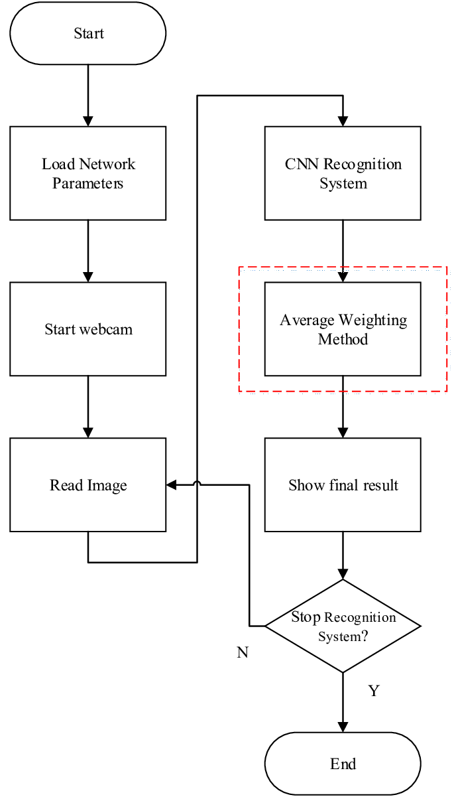As Fig 3.1 show the flow diagram for existing system. These existing system may have limitations in terms of accuracy and the ability to personalize music recommendations based on individual preferences. Therefore, there is still room for improvement and innovation in the field of facial emotion recognition with music recommendation using deep learning and TensorFlow.

Fig 3.1 Existing Flow

**3.2 PROPOSED SYSTEM**

Human facial expressions can be easily classified into 7 basic emotions: happy, sad, surprise, fear, anger, disgust, and neutral. Through facial emotion recognition, we are able to measure the effects that content and services have on the audience/users through an easy and low-cost procedure. Facial expressions are non-verbal clues to emotions. Indeed, some facial muscles are specifically associated with certain emotional states and allow, according to Ekman the expression of primary emotions (Sad, Anger, Fear, Joy, Disgust and Surprise). These external signals express the internal emotional state of an individual, and therefore his intentions. In fact, 7% of the communication relies on verbal interaction, 38% represent tone and sound of voice, 55% are articulated around gestures and expressions of the face according to Mehrabian.

**ADVANTAGES**

* As part of pre-processing, we performed dimension fixing(rescaling) as well as to increase the data volume for our model to train on we employed image augmentation on the images before they are fed to the neural network for prediction
* It will try to enhance the users’ mood.
* This system is better than static recommendation system as it will suggest music based on users’ mood by facial recognition and helps them to improve their mood.
* When employed deep neural network with transfer learning to extract the bottleneck features from JAFFE images dataset and fed these features to a set of fully connected layers to predict the facial emotions of these images.

**3.3 SYSTEM SPECIFICATION**

**HARDWARE CONFIGURATION**

* Processor - i5
* Speed - 3 GHz
* RAM - 8 GB (min)
* Hard Disk - 500 GB
* Key Board - Standard Windows Keyboard
* Mouse - Two or Three Button Mouse
* Monitor - SVGA

**SOFTWARE CONFIGURATION**

* Operating System - Linux, Windows/7/10
* Tools - Anaconda, Jupyter, PyCharm
* Server-side Script - Python.

**3.4 WHAT IS CNN?**

A Convolutional Neural Network (CNN) is a type of artificial neural network that is commonly used for image and video processing tasks. It consists of multiple layers of interconnected nodes that are designed to automatically learn and extract features from the input data.

The first layer in a CNN typically performs convolution, where a set of filters are applied to the input image to produce a set of feature maps. These feature maps are then passed through a non-linear activation function, such as ReLU, to introduce non-linearity into the model.

Subsequent layers in the network perform pooling operations, where the feature maps are downsampled to reduce their dimensionality and extract the most salient features. This process is repeated several times, with each subsequent layer learning higher-level features that are increasingly complex.

Finally, the output of the last layer is typically passed through a softmax function to produce a probability distribution over the possible output classes, allowing the network to make predictions.

Overall, CNNs are highly effective for image and video processing tasks, and have been used in a wide range of applications, including object recognition, face detection, and natural language processing.

Emotion detection using a Convolutional Neural Network (CNN) is a popular application of this technology. It involves training a CNN to analyze facial expressions and detect the emotions that are being expressed, such as happiness, sadness, anger, or fear.

To do this, the CNN is typically trained on a large dataset of labeled images that contain faces with known emotions. The first layer of the network performs convolution on the input image to extract low-level features, such as edges and corners. Subsequent layers perform pooling and convolution operations to extract higher-level features, such as facial features like eyes, nose, and mouth.

After the features are extracted, they are passed through a fully connected layer, which produces a set of output scores for each possible emotion. These scores are then passed through a softmax function to obtain a probability distribution over the possible emotions, allowing the network to predict which emotion is being expressed.

Emotion detection using CNNs has many potential applications, such as in market research, where companies can use it to analyze consumer reactions to their products or advertisements. It can also be used in mental health applications, where it can help diagnose and monitor mood disorders such as depression or anxiety. Overall, emotion detection using CNNs is a powerful tool that has the potential to transform a wide range of industries and applications.

**3.5 LANGUAGE DESCRIPTION**

**3.5.1 PYTHON**

Python is an interpreter, object-oriented, high-level programming language with dynamic semantics. Its high-level built in data structures, combined with dynamic typing and dynamic binding; make it very attractive for Rapid Application Development, as well as for use as a scripting or glue language to connect existing components together. Python's simple, easy to learn syntax emphasizes readability and therefore reduces the cost of program maintenance. Python supports modules and packages, which encourages program modularity and code reuse. The Python interpreter and the extensive standard library are available in source or binary form without charge for all major platforms, and can be freely distributed.

Often, programmers fall in love with Python because of the increased productivity it provides. Since there is no compilation step, the edit-test-debug cycle is incredibly fast. Debugging Python programs is easy: a bug or bad input will never cause a segmentation fault. Instead, when the interpreter discovers an error, it raises an exception. When the program doesn't catch the exception, the interpreter prints a stack trace. A source level debugger allows inspection of local and global variables, evaluation of arbitrary expressions, setting breakpoints, stepping through the code a line at a time, and so on. The debugger is written in Python itself, testifying to Python's introspective power. On the other hand, often the quickest way to debug a program is to add a few print statements to the source: the fast edit-test-debug cycle makes this simple approach very effective.It ranges from simple automation tasks to gaming, web development, and even complex enterprise systems. These are the areas where this technology is still the king with no or little competence: Machine learning as it has a plethora of libraries implementing machine learning algorithms.Python is a one-stop shop and relatively easy to learn, thus quite popular now. What other reasons exist for such universal popularity of this programming language and what companies have leveraged its opportunities to the max? Let’s talk about that. Python technology is quite popular among programmers, but the practice shows that business owners are also Python development believers and for good reason. Software developers love it for its straightforward syntax and reputation as one of the easiest programming languages to learn. Business owners or CTOs appreciate the fact that there’s a framework for pretty much anything – from web apps to machine learning. Moreover, it is not just a language but more a technology platform that has come together through a gigantic collaboration from thousands of individual professional developers forming a huge and peculiar community of aficionados. So what is python used for and what are the tangible benefits the language brings to those who decided to use it? Below we’re going to discover that. Productivity and Speed It is a widespread theory within development circles that developing Python applications is approximately up to 10 times faster than developing the same application in Java or C/C++. The impressive benefit in terms of time saving can be explained by the clean object-oriented design, enhanced process control capabilities, and strong integration and text processing capacities. Moreover, its own unit testing framework contributes substantially to its speed and productivity.

**3.5.2 PYCHARM**

PyCharm is a dedicated Python Integrated Development Environment (IDE) providing a wide range of essential tools for Python developers, tightly integrated to create a convenient environment for productive Python, web, and data science development.

Choose the best PyCharm for you﻿

**PyCharm is available in three editions:**

* Community (free and open-sourced): for smart and intelligent Python development, including code assistance, refactorings, visual debugging, and version control integration.
* Professional (paid) : for professional Python, web, and data science development, including code assistance, refactorings, visual debugging, version control integration, remote configurations, deployment, support for popular web frameworks, such as Django and Flask, database support, scientific tools (including Jupyter notebook support), big data tools.
* Edu (free and open-sourced): for learning programming languages and related technologies with integrated educational tools.
* For details, see the editions comparison matrix.

**Supported languages﻿**

To start developing in Python with PyCharm you need to download and install Python from python.org depending on your platform.

PyCharm supports the following versions of Python:

Python 2: version 2.7

Python 3: from the version 3.6 up to the version 3.10

Besides, in the Professional edition, one can develop Django, Flask, and Pyramid applications. Also, it fully supports HTML (including HTML5), CSS, JavaScript, and XML: these languages are bundled in the IDE via plugins and are switched on for you by default. Support for the other languages and frameworks can also be added via plugins (go to Settings | Plugins or PyCharm | Preferences | Plugins for macOS users, to find out more or set them up during the first IDE launch).

### **3.6 SUPPORTED PLATFORMS﻿**

|  |  |  |
| --- | --- | --- |
| **Requirement** | **Minimum** | **Recommended** |
| RAM | 4 GB of free RAM | 8 GB of total system RAM |
| CPU | Any modern CPU | Multi-core CPU. PyCharm supports multithreading for different operations and processes making it faster the more CPU cores it can use. |
| Disk space | 2.5 GB and another 1 GB for caches | SSD drive with at least 5 GB of free space |
| Monitor resolution | 1024x768 | 1920×1080 |
| Operating system | Officially released 64-bit versions of the following:   * Microsoft Windows 8 or later * macOS 10.13 or later * Any Linux distribution that supports Gnome, KDE, or Unity DE. PyCharm is not available for some Linux distributions, such as RHEL6 or CentOS6, that do not include [GLIBC](https://ftp.gnu.org/gnu/libc/) 2.14 or later.   Pre-release versions are not supported. | Latest 64-bit version of Windows, macOS, or Linux (for example, Debian, Ubuntu, or RHEL) |

**3.7 JUPYTER NOTEBOOK BASIC**

Fig 3.2 refers By default, a Jupyter notebook on CoCalc has all CoCalc’s core features, including real-time collaboration, side chat, and TimeTravel. Read more in our blogpost. The basic user interface looks like the following:

[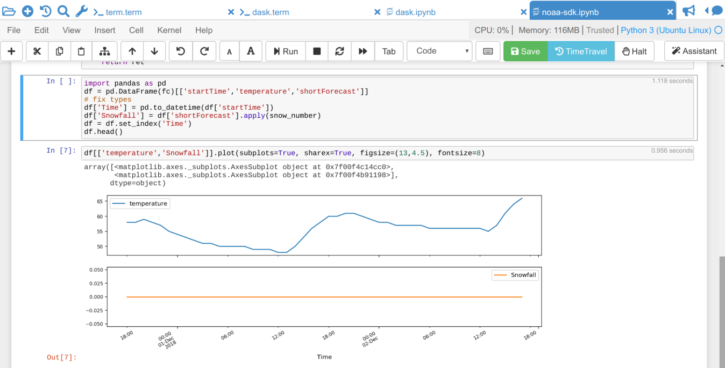](https://doc.cocalc.com/_images/jupyter-notebook-cocalc-1.png)

Fig 3.2 Jupyter Notebook

Above the main area is a menu bar and a button row:

• The menu bar contains all commands, and in particular the Kernel menu is for changing it if necessary.

• The button row gives you a one-click access to Run the current cell (otherwise press your Shift+Return keys), a way to restart the kernel (which clears the current session) and a Save button to make sure CoCalc has stored the file. The Time Travel button allows you to see previous versions of that notebook, such that you can go back in time to recover from a bad change.

• Active cell: in the screenshot above, the blue bar on the left and a blue border around a cell indicates that this is the currently active one. Actions like Run, Delete Cell, etc. operate on the currently selected cell. It is also possible to select more than one cell.

• Execution counter: On the left of each cell, there is an execution counter The number increases each time a cell is being run. After the kernel stopped and restarted, that counter starts again at 1.

• The output of code cells is below the input cell. For example, is the output of cell In the right hand corner of the input cell is some information about how long it took to calculate the result.

• Text cells are slightly different. Select “Markdown” in the dropdown menu in the button bar to change a code cell to such a markdown text cell. There, you can use Markdown to format the text. Similar to code-cells, either Run these text cells to see the processed Markdown code or press Shift+Return. To edit a text cell, either double click it or press your Return key.

• Saving: more general, the nice things about Jupyter Notebooks is that they save all your intput and output in one single file. This means you can download or publish the notebook as it is, and everyone else sees it in exactly the same way.

**ANACONDA PYTHON**

Anaconda® is a package manager, an environment manager, a Python/R data science distribution, and a collection of [over 7,500+ open-source packages](https://docs.anaconda.com/anaconda/packages/pkg-docs/). Anaconda is free and easy to install, and it offers free community support.

Get the Anaconda Cheat Sheet and then download Anaconda.

Want to install conda and use conda to install just the packages you need? Get [Miniconda](http://conda.pydata.org/miniconda.html).

**Anaconda Navigator or conda?**

After you install Anaconda or Miniconda, if you prefer a desktop graphical user interface (GUI) then use Navigator. If you prefer to use Anaconda prompt (or terminal on Linux or macOS), then use that and conda. You can also switch between them.

You can install, remove, or update any Anaconda package with a few clicks in Navigator, or with a single conda command in Anaconda Prompt (terminal on Linux or macOS).

* **To try Navigator**, after installing Anaconda, click the Navigator icon on your operating system’s program menu, or in Anaconda prompt (or terminal on Linux or macOS), run the command anaconda-navigator.
* **To try conda**, after installing Anaconda or Miniconda, take the 20-minute conda test drive and download a conda cheat sheet.

**Packages available in Anaconda**

* Over [250 packages](https://docs.anaconda.com/anaconda/packages/pkg-docs/) are automatically installed with Anaconda.
* Over 7,500 additional open-source packages (including R) can be individually installed from the Anaconda repository with the conda install  command.
* Thousands of other packages are available from Anaconda.org.
* You can download other packages using the pip install  command that is installed with Anaconda. Pip packages provide many of the features of conda packages and in some cases they can work together. However, the preference should be to install the conda package if it is available.
* You can also make your own custom packages using the conda build command, and you can share them with others by uploading them to Anaconda.org, PyPI, or other repositories.

**3.8 MODULE DESCRIPTION**

**3.8.1 Input Preprocessing Module**

**- Description**: Preprocessing operations are performed on the input image before feeding it into the CNN model.

**- Tasks**:

- Resize the input image to a fixed size suitable for the CNN model.

- Normalize the pixel values to bring them within a specific range (e.g., 0 to 1) to aid model training and inference.

- Convert the image to grayscale .

**3.8.2 Convolutional Neural Network (CNN) Module**

- **Description**: This module consists of a series of convolutional, pooling, and activation layers that learn meaningful features from the preprocessed image.

- **Tasks**:

- Apply multiple convolutional layers to extract low-level to high-level visual features from the input image.

- Use activation functions (e.g., ReLU) to introduce non-linearity and increase the model's expressive power.

- Apply pooling layers (e.g., max pooling) to downsample the spatial dimensions and capture the most relevant features.

**3.8.3 Emotion Classification Module**

- **Description**: This module employs deep learning techniques, specifically CNN models, for emotion classification based on the extracted features.

- **Tasks**:

- Train a CNN model using labeled facial expression datasets, where each image is associated with a specific emotion category.

- Feed the extracted features into the CNN model for prediction.

- Employ activation functions, pooling layers, fully connected layers, and softmax activation at the output to classify the emotions accurately.

**3.8.4 Music Recommendation Module**

- **Description**: This module provides personalized music recommendations based on the recognized facial emotions.

- **Tasks**:

- Consider factors such as the recognized emotion, user preferences, music attributes (e.g., tempo, genre), and contextual information.

- Generate personalized music recommendations that align with the user's emotional state

**3.9 SUMMARY**

The implementation of the Facial Emotion Recognition with Music Recommendation system involves the use of convolutional neural networks (CNNs) for facial emotion recognition. CNNs are deep learning algorithms that are widely used for image classification tasks, making them ideal for facial expression recognition.

The CNN architecture used in this project comprises multiple layers, including input, convolutional, pooling, and fully connected layers. The input layer receives the facial image as input, and the convolutional layers perform feature extraction by applying filters to the image. The pooling layers then reduce the spatial dimensionality of the extracted features, making them more computationally efficient. Finally, the fully connected layers process the extracted features and classify the facial expression into one of the six basic emotions: happiness, sadness, anger, disgust, fear, or surprise.

To train the CNN model, a dataset of labeled facial images was utilized, consisting of thousands of images from different sources. The images were preprocessed, including resizing, normalization, and data augmentation, to improve the model's performance. The CNN model was then trained using the preprocessed images and evaluated using a separate test dataset to assess its accuracy and performance.

Overall, the implementation of the CNN architecture for facial emotion recognition is a critical component of the Facial Emotion Recognition with Music Recommendation system. It enables the accurate detection and classification of facial expressions, providing the basis for personalized music recommendations based on the user's emotional state.

**CHAPTER 4**

**4. SYSTEM DESIGN**

**4.1 ARCHITECTURE DIAGRAM**

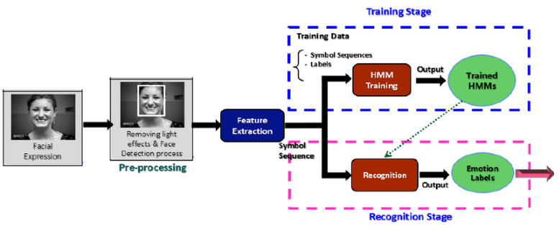

Input image

Fig 4.1 Dataset Training

Fig 4.1 & 4.2 represents the architecture diagram for facial emotion recognition. This contains the following components:

**Image dataset**: A collection of facial images is used as input data for training and testing the facial emotion recognition system.

**Pre-processing**: Necessary transformations and enhancements are applied to the face images, such as normalization or grayscale conversion, to prepare them for further processing.

**Feature Extraction**: Relevant features are extracted from the pre-processed face images to capture important information for emotion classification.

**CNN**: Convolutional Neural Networks (CNNs) are employed to learn hierarchical representations from the extracted features, capturing spatial dependencies within the face images.

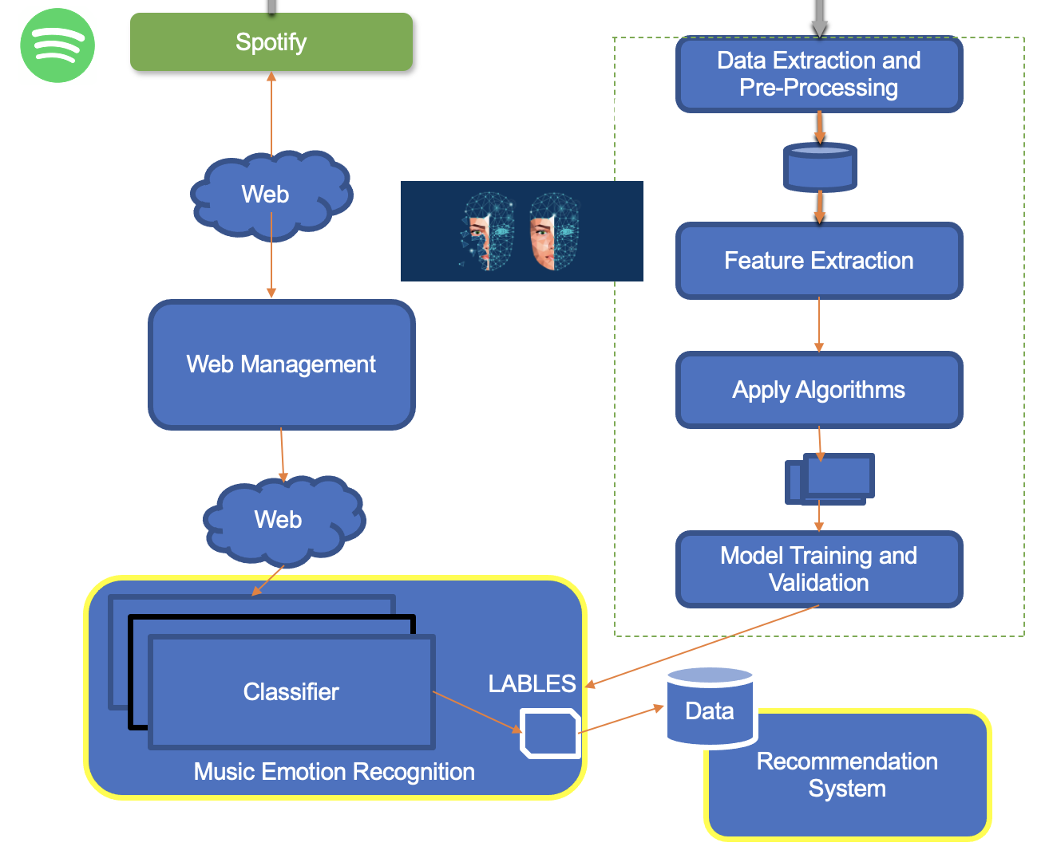

Fig 4.2 Architecture Diagram

**Emotion classification**: The trained CNN model is used to classify the emotions conveyed in the facial images, assigning labels such as happiness, sadness, anger, neutrality, or surprise to the input images.

**4.2 DATA FLOW DIAGRAM**

Fig 4.3 represents the data flow diagram (DFD) is a graphical representation of the "flow" of data through an information system, modeling its process aspects.

Dataset

Face Detection

Facial Feature Extraction

Emotion Classification

Input image

Pre Processing

Output/Identified Expression

Fig 4.3 DATA FLOW DIAGRAM

**4.3 CLASS DIAGRAM**

Fig 4.4 represents the class diagram in the Unified Modeling Language (UML) is a type of static structure diagram that describes the structure of a system by showing the system's classes, their attributes, operations (or methods), and the relationships among objects**.**

dataset

preprocessed

-format: .jpg

image

-format: .jpg

image

-format: .jpg

image

-format: .jpg

image

image

1 1

1

Face Detection

Emotion classification

1

result

Identified Expression

Fig 4.4 CLASS DIAGRAM

**4.4 SEQUENCE DIAGRAM**

Fig 4.5 represents the sequence diagram shows, as parallel vertical lines (*lifelines*), different processes or objects that live simultaneously, and, as horizontal arrows, the messages exchanged between them, in the order in which they occur.

user

Preprocessed input

Result: label

dataset

Dataset

Expression identification

Checks whether face expression

Fig 4.5 SEQUENCE DIAGRAM

**4.5 USE-CASE DIAGRAM**

Fig 4.6 represents the diagram where we have identified 2 actors in these diagrams, the actual Machine Users and the Unix Developers. The Machine user can; begin using the system – this represents whichever method the user will use in order to make initial interaction with the system.

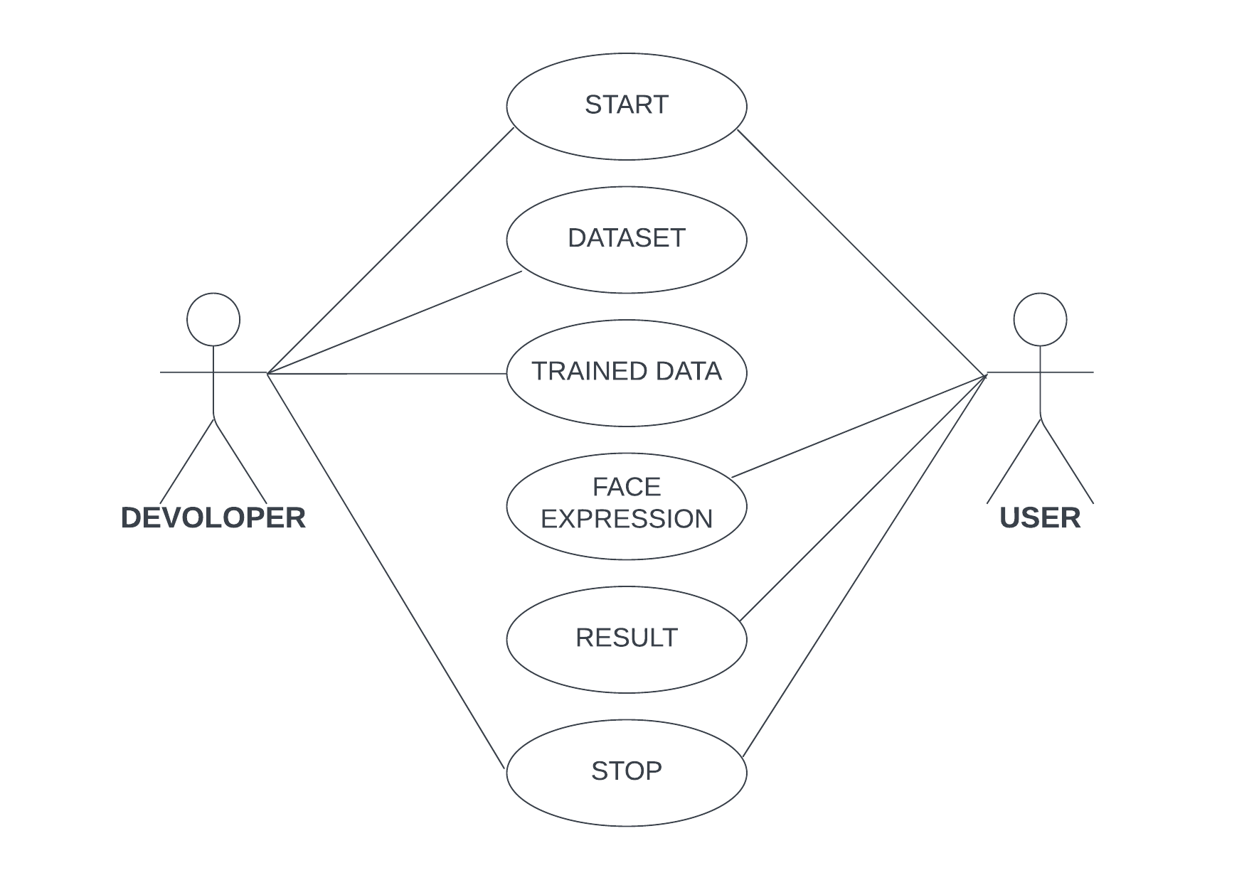

Fig 4.6 USE-CASE DIAGRAM

**4.6 SUMMARY**

The system design provides a comprehensive overview of the system's architecture, data flow, and interactions. It serves as a blueprint for the implementation phase, to achieve accurate emotion recognition and personalized music recommendations. The system design also incorporates deep learning techniques, such as convolutional neural networks (CNNs) and TensorFlow, for facial emotion recognition. These techniques enable the extraction of relevant features from facial images and the classification of emotions. Additionally, music recommendation algorithms are integrated into the system, considering the user's emotional state and preferences to generate personalized music recommendations

**CHAPTER 5**

**5. TESTING**

**5.1 SYSTEM TESTING AND MAINTENANCE**

Testing is vital to the success of the system. System testing makes a logical assumption that if all parts of the system are correct, the goal will be successfully achieved. In the testing process we test the actual system in an organization and gather errors from the new system operates in full efficiency as stated. System testing is the stage of implementation, which is aimed to ensuring that the system works accurately and efficiently.

In the testing process we test the actual system in an organization and gather errors from the new system and take initiatives to correct the same. All the front-end and back-end connectivity are tested to be sure that the new system operates in full efficiency as stated. System testing is the stage of implementation, which is aimed at ensuring that the system works accurately and efficiently.

The main objective of testing is to uncover errors from the system. For the uncovering process we have to give proper input data to the system. So we should have more conscious to give input data. It is important to give correct inputs to efficient testing.

Testing is done for each module. After testing all the modules, the modules are integrated and testing of the final system is done with the test data, specially designed to show that the system will operate successfully in all its aspects conditions. Thus the system testing is a confirmation that all is correct and an opportunity to show the user that the system works. Inadequate testing or non-testing leads to errors that may appear few months later.

This will create two problems, Time delay between the cause and appearance of the problem. The effect of the system errors on files and records within the system. The purpose of the system testing is to consider all the likely variations to which it will be suggested and push the system to its limits.

The testing process focuses on logical intervals of the software ensuring that all the statements have been tested and on the function intervals (i.e.,) conducting tests to uncover errors and ensure that defined inputs will produce actual results that agree with the required results. Testing has to be done using the two common steps Unit testing and Integration testing. In the project system testing is made as follows:

**5.2 METHOD**

Any of Black Box Testing, White Box Testing, and Gray Box Testing methods can be used. Normally, the method depends on your definition of ‘unit’.

TASKS

➢ Integration Test Plan

▪ Prepare

▪ Review

▪ Rework

▪ Baseline

➢ Integration Test Cases/Scripts

▪ Prepare

▪ Baseline

➢ Integration Test

▪ Perform

**5.3 UNIT TESTING**

Unit testing verification efforts on the smallest unit of software design, module. This is known as “Module Testing”. The modules are tested separately. This testing is carried out during programming stage itself. In these testing steps, each module is found to be working satisfactorily as regard to the expected output from the module.

**5.4 BLACK BOX TESTING**

Black box testing, also known as Behavioral Testing, is a software testing method in which the internal structure/ design/ implementation of the item being tested is not known to the tester. These tests can be functional or non-functional, though usually functional.

**5.5 WHITE-BOX TESTING**

White-box testing (also known as clear box testing, glass box testing, transparent box testing, and structural testing) is a method of testing software that tests internal structures or workings of an application, as opposed to its functionality (i.e. black-box testing).

**5.6 GREY BOX TESTING**

Grey box testing is a technique to test the application with having a limited knowledge of the internal workings of an application. To test the Web Services application usually the Grey box testing is used. Grey box testing is performed by end-users and also by testers and developers.

**5.7 INTEGRATION TESTING**

Integration testing is a systematic technique for constructing tests to uncover error associated within the interface. In the project, all the modules are combined and then the entire programmer is tested as a whole. In the integration-testing step, all the error uncovered is corrected for the next testing steps.

Software integration testing is the incremental integration testing of two or more integrated software components on a single platform to produce failures caused by interface defects.

The task of the integration test is to check that components or software applications, eg. components in a software system or – one step up – software applications at the company level – interact without error.

**5.8 ACCEPTANCE TESTING**

User Acceptance Testing is a critical phase of any project and requires significant participation by the end user. It also ensures that the system meets the functional requirements.

**Acceptance testing for Data Synchronization:**

➢ The Acknowledgements will be received by the Sender Node after the Packets are received by the Destination Node

➢ The Route add operation is done only when there is a Route request in need

➢ The Status of Nodes information is done automatically in the Cache Updating process

**5.9 BUILD THE TEST PLAN**

Any project can be divided into units that can be further performed for detailed processing. Then a testing strategy for each of this unit is carried out. Unit testing helps to identity the possible bugs in the individual component, so the component that has bugs can be identified and can be rectified from errors.

**5.10 SUMMARY**

The testing phase of the Facial Emotion Recognition with Music Recommendation system involved the application of various testing methodologies to ensure the system's functionality, accuracy, and reliability.

Throughout the testing phase, comprehensive test cases were designed and executed, covering various scenarios and edge cases. Test results were recorded and analyzed to identify and address any defects or inconsistencies in the system's functionality. Test reports were generated, providing a summary of the testing process, identified issues, and their resolutions.

By employing these testing methodologies, the Facial Emotion Recognition with Music Recommendation system underwent rigorous evaluation to ensure its robustness, accuracy, and user satisfaction. The testing phase played a crucial role in identifying and rectifying any potential issues, thereby ensuring the system's reliability and effectiveness.

**CHAPTER 6**

**6. CONCLUSION**

In this project, we presented a model to recommend music based on the emotion which is detected from the facial expression. This project proposed designed and developed an emotion-based music recommendation system using face recognition system. Music is the one that has the power to heal any stress or any kind of emotions. Recent development promises a wide scope in developing emotion-based music recommendation system. Thus, the proposed system presents face-based emotion recognition system to detect the emotions and play music from the emotion detected. To make this model more effective, the model can be trained with images taken on varied conditions like angles, light conditions, colors, etc. which will enhance the performance of the model so that in future it can work on video clippings which will predict expressions in real time and prepare an integrated system such that the predictions made by the model would be displayed on a screen with best recommendations. We plan to design an end system such that when this system captures images of the employees over a predefined period of time then based on the classifications the system could propose some fruitful activities to the employees so which are proven to help and get over any critical mood condition.

**APPENDIX**

**SOURCECODE:**

**DATASET TRAINING:**

import pandas as pd

importnumpy as np

importmatplotlib.pyplot as plt

importos

import cv2

importtensorflow as tf

tf.__version__

fromtensorflow.keras.layers import Dense,Dropout,Flatten

fromtensorflow.keras.models import Sequential

fromtensorflow.keras.preprocessing.image import ImageDataGenerator

fromtensorflow.keras.layers import Convolution2D

fromtensorflow.keras.layers import MaxPooling2D

fromsklearn.metrics import classification_report

model=Sequential()

model.add(Convolution2D(64,(5,5),input_shape=(48,48,1),activation='relu'))

model.add(Convolution2D(64,(5,5),activation='relu'))

model.add(MaxPooling2D(pool_size=(2,2)))

model.add(Dropout(0.4))

model.add(Convolution2D(128,(3,3),activation='relu'))

model.add(Convolution2D(128,(3,3),activation='relu'))

model.add(MaxPooling2D(pool_size=(2,2)))

model.add(Dropout(0.4))

model.add(Flatten())

model.add(Dense(units=128,activation='relu'))

model.add(Dense(units=7,activation='softmax'))

model.summary()

model.compile(loss='categorical_crossentropy',optimizer='adam',metrics=['accuracy'])

train_datagen = ImageDataGenerator(

rescale=1./255,

rotation_range=30,

shear_range=0.3,

zoom_range=0.3,

horizontal_flip=False)

test_datagen = ImageDataGenerator(rescale=1./255)

train_generator = train_datagen.flow_from_directory(

'/content/Training',

target_size=(48,48),

batch_size=512,

color_mode="grayscale",

class_mode='categorical')

validation_generator = test_datagen.flow_from_directory(

'/content/Testing',

target_size=(48,48),

batch_size=512,

color_mode="grayscale",

class_mode='categorical')

filepath = os.path.join("./emotion_detector_models/model_v{epoch}.hdf5")

checkpoint = tf.keras.callbacks.ModelCheckpoint(filepath,

monitor='val_accuracy',

verbose=1,

save_best_only=True,

mode='max')

callbacks = [checkpoint]

nb_train_samples = 28709

nb_validation_samples = 7178

batch_size=512

history=model.fit_generator(

train_generator,

steps_per_epoch=nb_train_samples// batch_size,

epochs=50,

validation_data=validation_generator,

callbacks = callbacks,

validation_steps=nb_validation_samples // batch_size)

fig,(ax1,ax2)=plt.subplots(nrows=1,ncols=2,figsize=(20,6))

ax1.plot(history.history['accuracy'],label='train_accuracy')

ax1.plot(history.history['val_accuracy'],label='test_accuracy')

ax1.legend()

ax2.plot(history.history['loss'],label='train_loss')

ax2.plot(history.history['val_loss'],label='test_loss')

ax2.legend()

plt.show()

**MAIN SOURCECODE:**

importtensorflow as tf

fromtensorflow.keras.models import load_model

fromtensorflow.keras.preprocessing.image import img_to_array

import cv2

importnumpy as np

face_classifier = cv2.CascadeClassifier('./Harcascade/haarcascade_frontalface_default.xml')

classifier=load_model('./Models/model_v_47.hdf5')

class_labels={0: 'Angry', 1: 'Disgust', 2: 'Fear', 3: 'Happy', 4: 'Neutral', 5: 'Sad', 6: 'Surprise'}

cap = cv2.VideoCapture(0)

while True:

ret,img = cap.read()

gray=cv2.cvtColor(img,cv2.COLOR_BGR2GRAY)

faces = face_classifier.detectMultiScale(gray, 1.3, 5)

allfaces = []

rects = []

for (x, y, w, h) in faces:

cv2.rectangle(img, (x, y), (x+w, y+h), (255, 0, 0), 2)

roi_gray = gray[y:y+h, x:x+w]

roi_gray = cv2.resize(roi_gray, (48, 48), interpolation=cv2.INTER_AREA)

allfaces.append(roi_gray)

rects.append((x, w, y, h))

i = 0

for face in allfaces:

roi = face.astype("float") / 255.0

roi = img_to_array(roi)

roi = np.expand_dims(roi, axis=0)

preds = classifier.predict(roi)[0]

label = class_labels[preds.argmax()]

label_position = (rects[i][0] + int((rects[i][1]/2)),

abs(rects[i][2] - 10))

i = + 1

cv2.putText(img, label, label_position,

cv2.FONT_HERSHEY_SIMPLEX, 1, (0, 255, 0), 2)

cv2.imshow("MENTAL HEALTH IDENTIFICATION",img)

if cv2.waitKey(1) == 13: # 13 is the Enter Key

break

cap.release()

cv2.destroyAllWindows(

**SNAP-SHOTS OUTPUT**

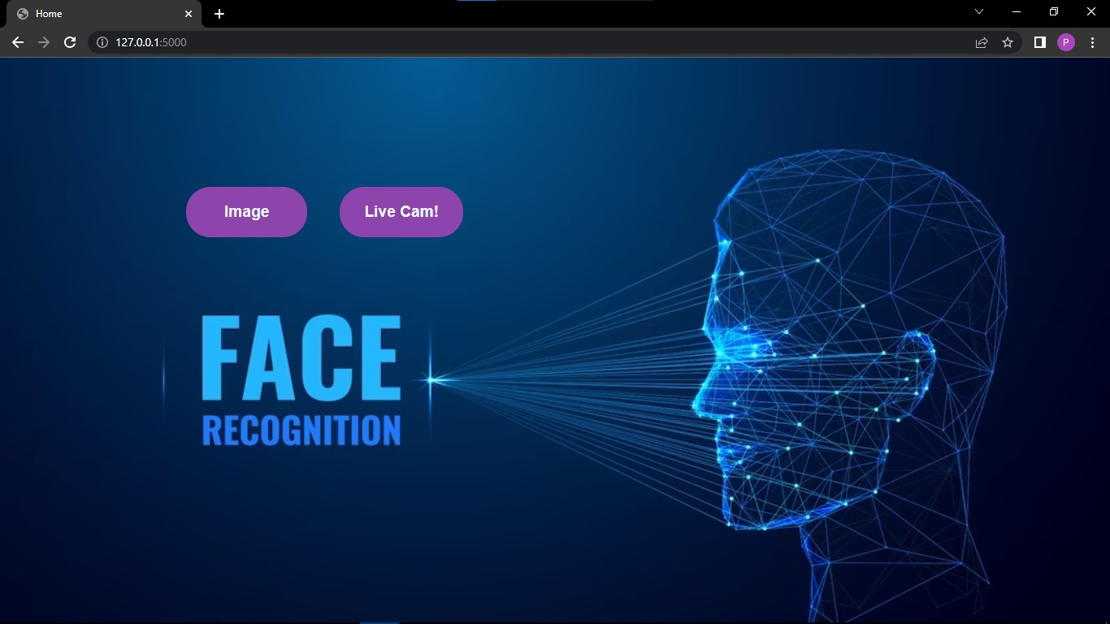

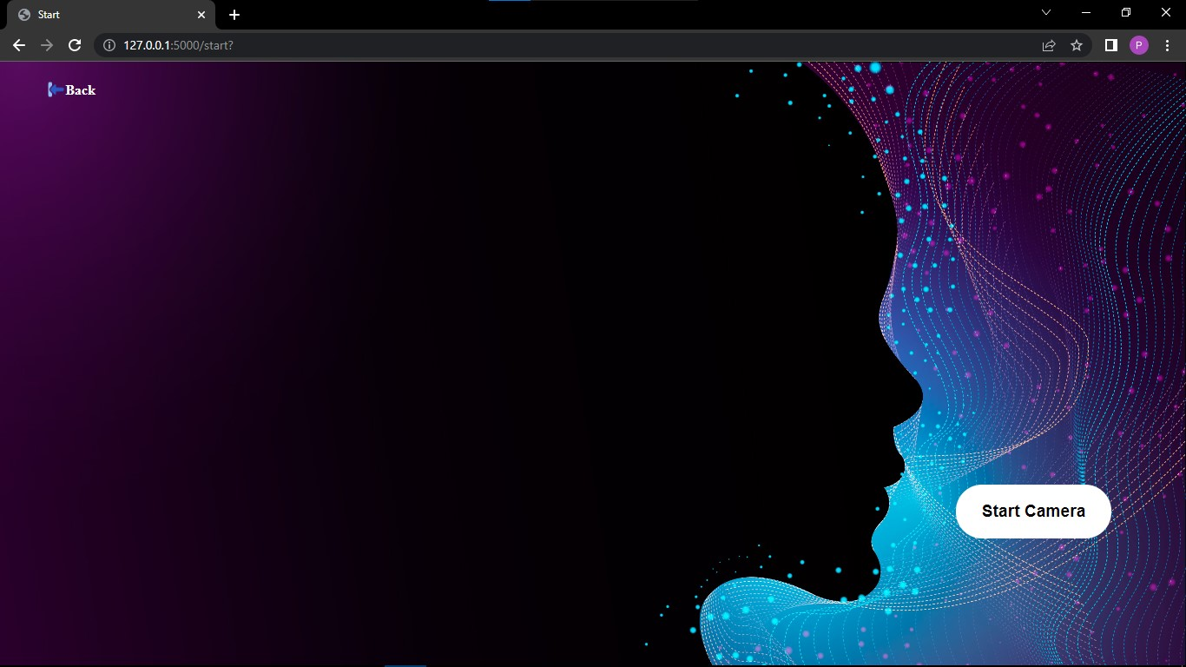

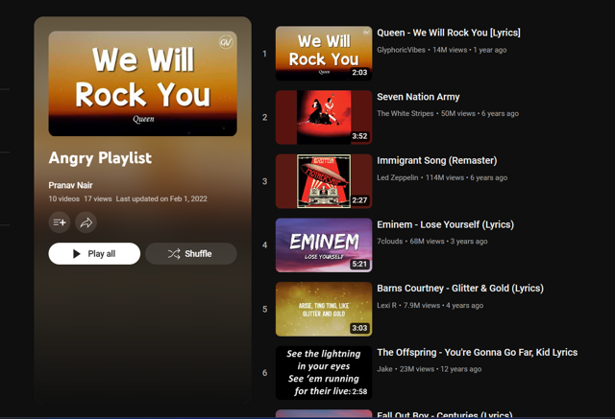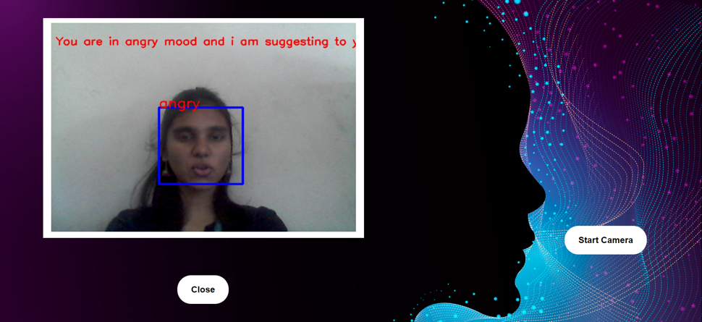

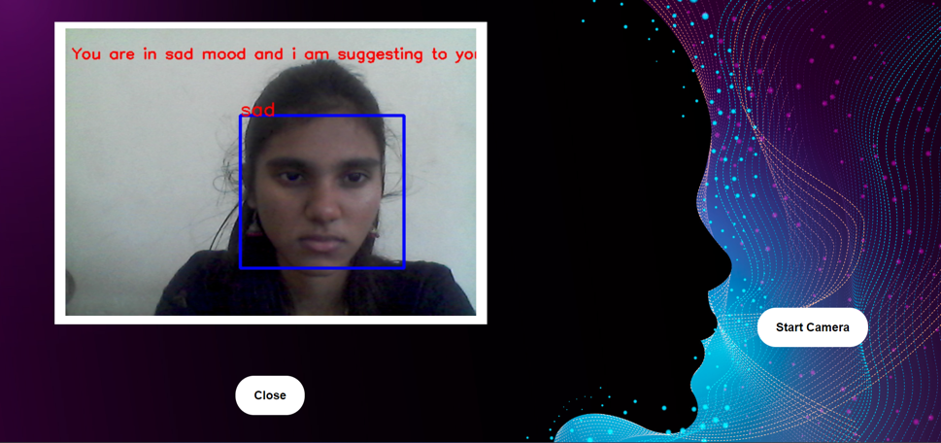



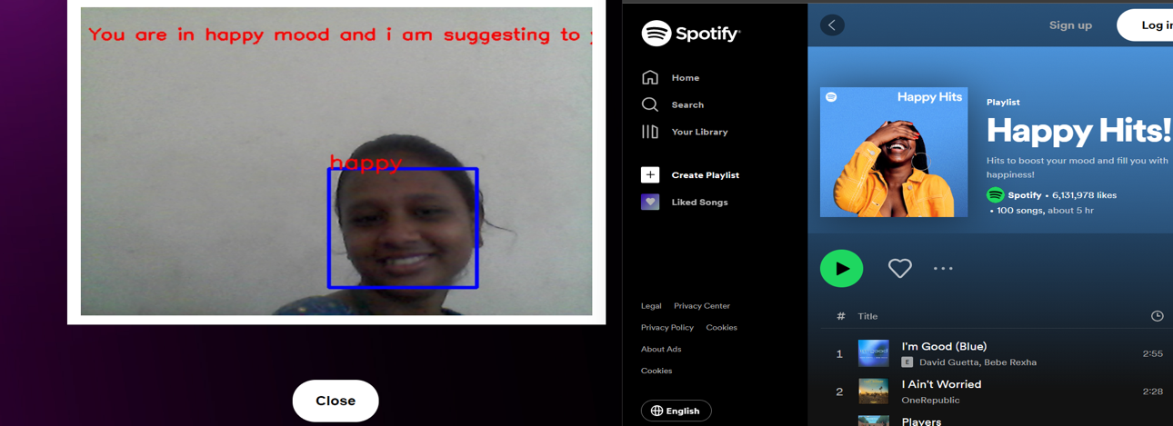

**FACIAL EMOTION RECOGINITION USING DEEP LEARNING AND TENSORFLOW BASED MUSIC RECOMMENDATION SYSTEM**

MS. Suganthi D Roszhan Raj M S Maya Padhy

Department of Computer Science and Engineering, Department of Computer Science and Engineering, Department of Computer Science and Engineering,

Rajalakshmi Institute of Technology Chennai, India. Rajalakshmi Institute of Technology Chennai, India. Rajalakshmi Institute of Technology Chennai, India.

[suganthi.d@ritchennai.edu.in](mailto:suganthi.d@ritchennai.edu.in) [roszhanraj.ms.2019.cse@ritchennai.edu.in](mailto:roszhanraj.ms.2019.cse@ritchennai.edu.in) [mayapadhy.2019.cse@ritchennai.edu.in](mailto:mayapadhy.2019.cse@ritchennai.edu.in)

1. **Abstract:**

This study is an attempt to understand and address the mental health issue, of working professionals through facial expression recognition and suggest a list of appropriate songs that can improve his mood. A brief search was conducted on how music can affect the user mood in short-term to gain knowledge and enable us to provide the users with a list of music tracks that work well on improving the user moods. As a society, we are all currently talking about ways as to how a person who is suffering from any emotional issue can adopt certain ways to come out of a specific circumstance and how we as a society can support such people in these situations. Our endeavor is to work on a way where the identification of such persons who are going through a difficult phase in their life can be performed. Our endeavor is to work on a way where the identification of such persons who are going through a difficult phase in their life can be performed. It is not always evident that a person going through a tough phase may open up about their feelings to people around them and hence making use of AI/ML to identify a person’s emotion through their facial expressions captured over a span of time thereby recommending them some activities, thoughts which can help them in getting over their emotions when they are sad, fearful its suggestion the music.

1. **INTRODUCTION:**

A technology called facial emotion recognition is used to evaluate emotions in various media, including photos and videos. It is a member of the group of technologies known as "affective computing," which is a multidisciplinary field of study on how well computers can understand and recognise affective states and human emotions. Affective computing frequently builds on Artificial Intelligence technologies.

Human emotions can be inferred from facial expressions, which are a form of non-verbal communication. Decoding these emotional expressions has long been a subject of study in psychology.

The widespread use of cameras as well as recent advancements in machine learning, pattern recognition, and biometrics analysis have all been significant factors in the development of FER technology.

Many businesses, from tech behemoths like NEC or Google to smaller ones like Affectiva or Eyeris invest in the technology, demonstrating its growing importance. Three steps compose FER analysis:

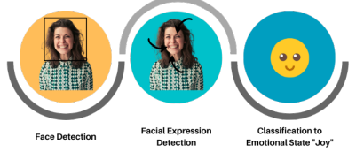a) face recognition

b) facial expression recognition

c) assigning an emotional state to a facial expression.

The examination of facial landmark positions, such as the end of the nose and the brows, forms the basis for emotion recognition. Additionally, in videos, changes in those positions are also examined in order to spot facial muscle contractions. Faces can indicate fundamental emotions (such as anger, disgust, fear, joy, sadness, and surprise) or compound emotions (such as happily sad, happily surprised, happily disgusted, tragically afraid, sadly angry, sadly surprised), depending on the algorithm.

Surveillance cameras, cameras near billboards in businesses, social media, streaming services, and personal devices are some of the sources of the photos and videos used as input by FER algorithms.

Artificial neurons that receive and analyse incoming data make up a neural network. The input layer, the hidden layer, and the output layer all receive data.

When input data is provided to a neural network, it begins to function. The intended result is subsequently produced by processing the data through its layers.

A neural network generates results after learning from structured data. There are three types of learning that can occur within neural networks:

• Supervised Learning: Inputs and outputs are given to the algorithms using labelled data. After receiving training on how to evaluate data, they then anticipate the intended outcome.

• Unsupervised Learning - Without human supervision, ANNs learn. The output is decided based on patterns found in the output data; there is no labelled data

• Reinforcement learning: Based on the feedback you provide, the network adapts.

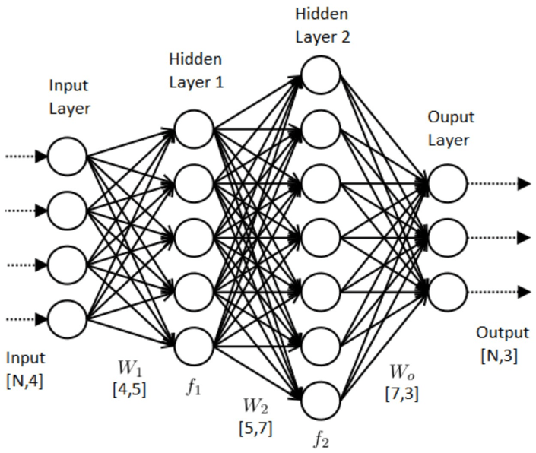

**Process of Neural Network**

1. **Methodology:**

* Module description:

We used a deep neural network using transfer learning approach to extract bottle attributes from the input photos and save these features in order to achieve the goal. Later, the bottle features are loaded back into a network of fully connected layers, and the images are then sent to the model for prediction.

* Data-Pre-Processing:

Before the photos were supplied to the neural network for prediction, we performed dimension Fixing (rescaling) as part of the pre-processing and used image augmentation to boost the data volume for our model to train on.

* Using Neural Network:

To extract the bottleneck characteristics from the JAFFE image dataset, we used a deep neural network using transfer learning. We then fed these features to a set of fully connected layers to predict the face emotions in these photos. Before formatting, finalise content and organisational editing.

* Using CNN Layers:

A CNN is a particular type of network design for deep learning algorithms that is utilised for tasks like image recognition and pixel data processing. Although there are other kinds of neural networks in deep learning, CNNs are the preferred network architecture for identifying and recognising objects.

1. **SYSTEM SPECIFICATION**

**HARDWARE CONFIGURATION:**

|  |  |
| --- | --- |
| Processor | i5 |
| Speed | 3 GHz |
| RAM | 8 GB |
| Hard Disk | 500 GB |
| Keyboard | Standard |
| Mouse | Two or Three Button Mouse |

**SOFTWARE CONFIGURATION:**

|  |  |
| --- | --- |
| Operating System | Windows10 |
| Tools | Flask, Anaconda, Jupyter, PyCharm. |
| Server-side Script | Python. |

**ARCHITECTURE DIAGRAM:**

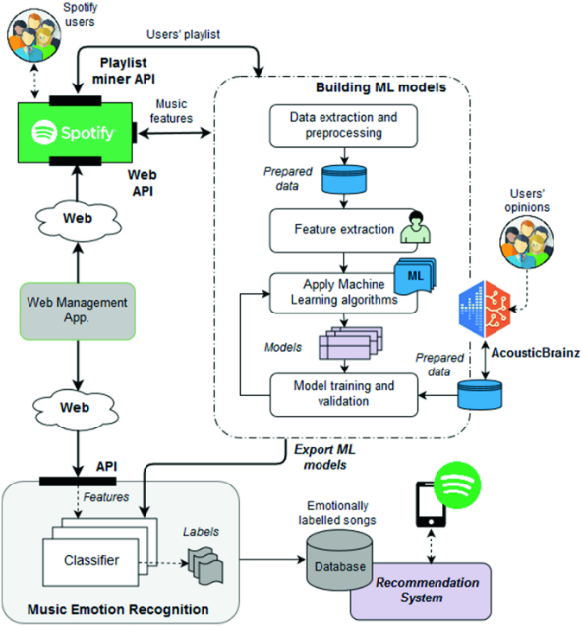

Process of Connecting Spotify to the System

1. **Limitations:**

There is a lot of commotion about facial recognition technology. There is, however, a great deal of discussion about privacy, dependability, potential bias, and a lack of control. Companies must be aware of any facial recognition technology restrictions as a result. The four drawbacks of facial recognition technology are as follows:

1. **Poor Image Quality:**

Image quality has an effect on how well facial recognition systems work. The scanned video's quality pales in comparison to that of a digital camera. Even high resolution video, which can be as high as 1080p, is commonly 720p. The corresponding amounts are roughly 2MP and 0.9MP, while a cheap digital camera may be able to capture 15MP. The distinction is easily discernible.

1. **Small Image Sizes:**

When a face-detection algorithm spots a face in an image or in a still from a video recording, how successfully it will be recognised relies on its proportion to the size of the entire image. Due to the already small image size and the target's distance from the camera, the recognised face can only be seen at a width of 100 to 200 pixels. Furthermore, scanning an image for various face sizes requires a lot of processing power. The majority of algorithms allow for the selection of a face-size range in order to decrease false positives during detection and speed up image processing.

1. **Different Face Angles:**

The recognition score is significantly influenced by the target's face's relative angle. Typically, when adding a face to facial recognition software, multiple angles are used. Any view other than a frontal view affects the algorithm's ability to build a face template

1. **Data Processing and Storage:**

Even though the resolution of the high-definition video is much lower than that of digital camera images, it still consumes a lot of disc space. Processing every single frame of video would be a laborious task, thus only about 10% to 25% of videos are normally exposed to a recognition system. Computer clusters are a tool that agencies can use to speed up processing overall. Although adding computers necessitates a lot of data transfer through a network, processing may be further slowed down by I/O.

1. **Existing Flow:**
2. **Conclusion:**

The goal of face emotion recognition (FER) is to recognise a person's emotions. The face can convey the emotion. Psychological traits including speech, hand gestures, bodily movements, and facial expressions help to determine a person's emotions.

You might feel happy, sad, mad, pumped up, calm, etc. when listening to music, and occasionally you might experience more than one feeling at once. According to study, music not only influences our moods, but we also appear to have a habit of selecting music based on how we are feeling at the time.

Simply acknowledging the emotions we are wired to feel is emotional expression. Healthy emotional expression enables us to process our feelings, feel them fully, and move on. We should all be able to identify the basic six emotions that all people are born with.Although emotions are shared by all people, how they are felt varies greatly from person to person. We do not experience anger in the same ways, nor do we experience anger in the same ways or display anger in the same ways. Our culture, peer groups, and personal experiences all shape who we are.

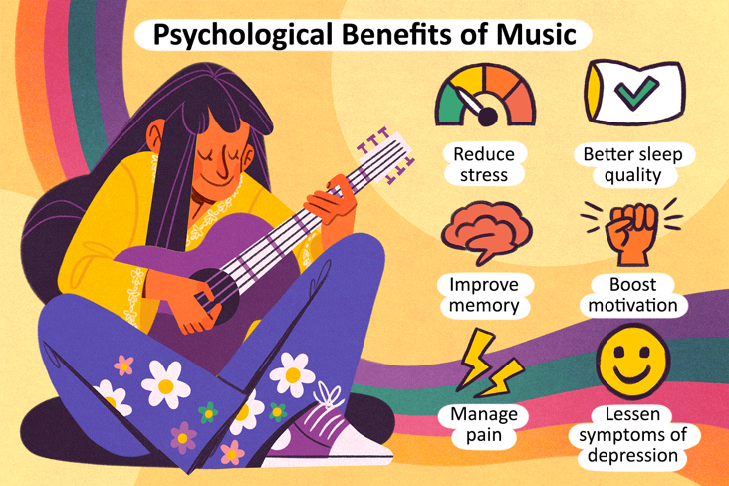

Effects of music in human.

H. **References:**

[1] Z. Zhang and M. Li, "Research on Facial Expression Recognition Based on Neural Network," 2020 International Conference on Computer Network, Electronic and Automation (ICCNEA), Xi'an, China, 2020, pp. 78-81, doi: 10.1109/ICCNEA50255.2020.00025.

[2] C. Jonitta Meryl, K. Dharshini, D. Sujitha Juliet, J. Akila Rosy and S. S. Jacob, "Deep Learning based Facial Expression Recognition for Psychological Health Analysis," 2020 International Conference on Communication and Signal Processing (ICCSP), Chennai, India, 2020, pp. 1155-1158, doi: 10.1109/ICCSP48568.2020.9182094.

[3] S. Liu, D. Li, Q. Gao and Y. Song, "Facial Emotion Recognition Based on CNN," 2020 Chinese Automation Congress (CAC), Shanghai, China, 2020, pp. 398-403, doi: 10.1109/CAC51589.2020.9327432.

[4] F. M. Sadikoğlu and M. Idle Mohamed, "Facial Expression Recognition Using CNN," 2022 International Conference on Artificial Intelligence in Everything (AIE), Lefkosa, Cyprus, 2022, pp. 95-99, doi: 10.1109/AIE57029.2022.00025.

[5] R. Jaiswal, "Facial Expression Classification Using Convolutional Neural Networking and Its Applications," 2020 IEEE 15th International Conference on Industrial and Information Systems (ICIIS), RUPNAGAR, India, 2020, pp. 437-442, doi: 10.1109/ICIIS51140.2020.9342664.

[6] S. D. Deb, C. Choudhury, M. Sharma, F. A. Talukdar and R. H. Laskar, "Frontal Facial Expression Recognition using Parallel CNN Model," 2020 National Conference on Communications (NCC), Kharagpur, India, 2020, pp. 1-5, doi: 10.1109/NCC48643.2020.9056011.

[7] P. Zarbakhsh, N. A. Golilarz and U. Ozgunalp, "Facial Expression Recognition System Using a Neural Network and Simulation on FPGA," 2020 IEEE 5th International Conference on Signal and Image Processing (ICSIP), Nanjing, China, 2020, pp. 21-25, doi: 10.1109/ICSIP49896.2020.9339442.

[8] S. Giri et al., "Emotion Detection with Facial Feature Recognition Using CNN & OpenCV," 2022 2nd International Conference on Advance Computing and Innovative Technologies in Engineering (ICACITE), Greater Noida, India, 2022, pp. 230-232, doi: 10.1109/ICACITE53722.2022.9823786.

[9] D. E. Cahyani, A. P. Wibawa, D. D. Prasetya, L. Gumilar, F. Akhbar and E. R. Triyulinar, "Emotion Detection in Text Using Convolutional Neural Network," 2022 International Conference on Electrical and Information Technology (IEIT), Malang, Indonesia, 2022, pp. 372-376, doi: 10.1109/IEIT56384.2022.9967913.

[10] F. N. Azizi, A. Kurniawardhani and I. V. Paputungan, "Facial Expression Image based Emotion Detection using Convolutional Neural Network," 2022 IEEE 20th Student Conference on Research and Development (SCOReD), Bangi, Malaysia, 2022, pp. 157-162, doi: 10.1109/SCOReD57082.2022.9974104.

[11] S. Joshi, T. Jain and N. Nair, "Emotion Based Music Recommendation System Using LSTM - CNN Architecture," 2021 12th International Conference on Computing Communication and Networking Technologies (ICCCNT), Kharagpur, India, 2021, pp. 01-06, doi: 10.1109/ICCCNT51525.2021.9579813.

[12] S. R, N. C, V. S, V. P. R, N. A and N. P. S. M, "Spotify Genre Recommendation Based On User Emotion Using Deep Learning," 2022 Fifth International Conference on Computational Intelligence and Communication Technologies (CCICT), Sonepat, India, 2022, pp. 422-426, doi: 10.1109/CCiCT56684.2022.00081.

[13] J. Li, C. Wen, J. Zhang, Y. Gan, G. Rui and J. Yao, "Emotion Detection Based on De-expression Residue Learning and Its Intelligent System Design," 2022 3rd International Conference on Intelligent Design (ICID), Xi’an, China, 2022, pp. 264-268, doi: 10.1109/ICID57362.2022.9969703.

[14] H. Kim, J. Ben-othman, L. Mokdad and P. Bellavista, "A Virtual Emotion Detection Architecture With Two-Way Enabled Delay Bound toward Evolutional Emotion-Based IoT Services," in IEEE Transactions on Mobile Computing, vol. 21, no. 4, pp. 1172-1181, 1 April 2022, doi: 10.1109/TMC.2020.3024059.

**ACCEPTANCE SCREENSHOT**

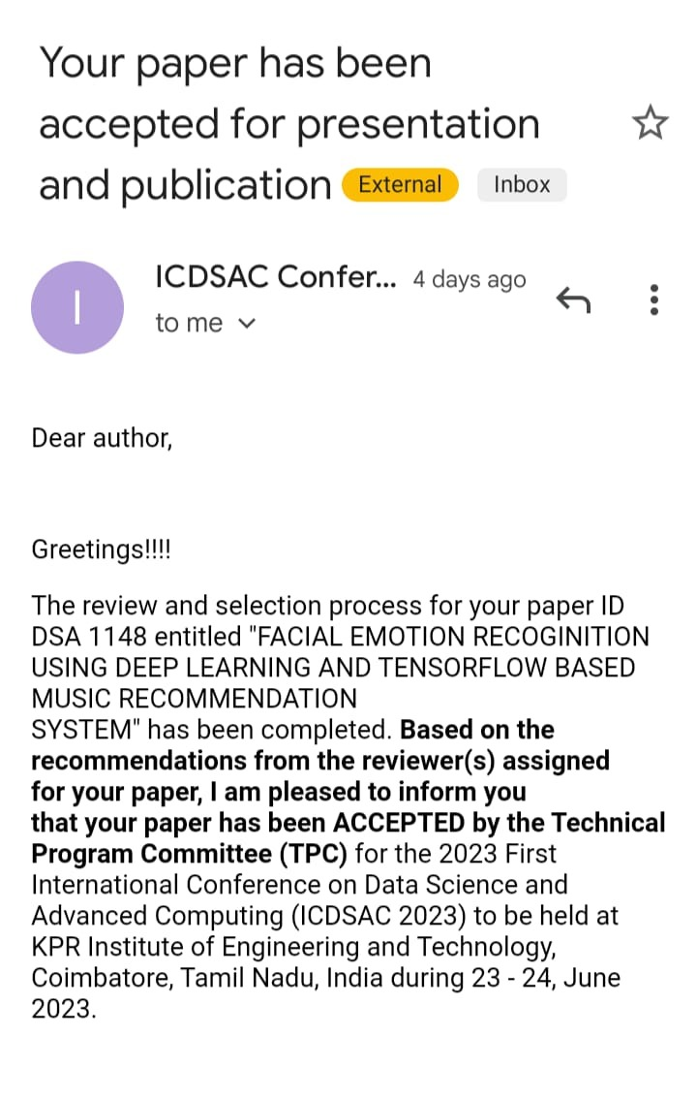

**CHAPTER 7**

**7. REFERENCE**

[1] Keras Team, “Keras documentation: VGG16 and VGG19,” Keras.io. [Online]. Available: https://keras.io/api/applications/vgg/.

[2] D. Dagar, A. Hudait, H. K. Tripathy, and M. N. Das, “Automatic emotion detection model from facial expression,” in 2016 International Conference on Advanced Communication Control and Computing Technologies (ICACCCT), 2016, pp. 77–85.

[3] A. De and A. Saha, “A comparative study on different approaches of real time human emotion recognition based on facial expression detection,” in 2015 International Conference on Advances in Computer Engineering and Applications, 2015, pp. 483–487.

[4] O. Martin, I. Kotsia, B. Macq and I. Pitas, "The eNTERFACE' 05 Audio- Visual Emotion Database," 22nd International Conference on Data Engineering Workshops (ICDEW'06), Atlanta, GA, USA, 2006, pp. 8- 8, doi: 10.1109/ICDEW.2006.145.

[5] “EmotiW2020,” Google.com. [Online]. Available: https://sites.google.com/view/emotiw2020.

[6] Researchgate.net. [Online]. Available: https://www.researchgate.net/ publication/224165246_The_Extended_Cohn-Kanade_Dataset_ CK_A_complete_dataset_for_action_unit_and_emotionspecified_expression. . [7] M. Lyons, M. Kamachi, and J. Gyoba, The Japanese female facial expression (JAFFE) database. 1998.

[8] D. F. T. Orozco, C. Lee, Y. Arabadzhi, and V. K. Gupta, “Transfer learning for Facial Expression Recognition,” 2018.

[9] Keras Team, “Keras documentation: InceptionV3,” Keras.io. [Online]. Available: https://keras.io/api/applications/inceptionv3/.

[10] “ImageNet,” Image-net.org. [Online]. Available: http://www.imagenet.org/. [11] Keras Team, “Keras documentation: Adam,” Keras.io. [Online]. Available: https://keras.io/api/optimizers/adam/. .

[12] Keras Team, “Keras documentation: Convolution layers,” Keras.io. [Online]. Available: https://keras.io/api/layers/convolution_layers/. .

[13] “Confusion matrix — scikit-learn 0.23.2 documentation,” Scikitlearn.org. [Online]. Available: https://scikitlearn.org/stable/auto_examples/model_selection/plot_confusion_matrix .html. .

[14] E. M. Dogo, O. J. Afolabi, N. I. Nwulu, B. Twala and C. O. Aigbavboa, "A Comparative Analysis of Gradient Descent-Based Optimization Algorithms on Convolutional Neural Networks," 2018 International Conference on Computational Techniques, Electronics and Mechanical Systems (CTEMS), Belgaum, India, 2018, pp. 92-99, doi: 10.1109/CTEMS.2018.8769211.

[15] P. Pai, “Data Augmentation Techniques in CNN using Tensorflow,” Medium, 25-Oct-2017.[Online]. Available: https://medium.com/@prasad.pai/data-augmentation-techniques-incnn-using-tensorflow-371ae43d5be9. .

[16] “Data augmentation | TensorFlow Core,” Tensorflow.org. [Online]. Available: https://www.tensorflow.org/tutorials/images/data_augmentation.

[17] V. Agarwal, “Complete Image Augmentation in OpenCV | Towards Data Science,” Towards Data Science, 13-May-2020. [Online]. Available: https://towardsdatascience.com/complete-imageaugmentation-in-opencv-31a6b02694f5.

[18] “‘Silent Messages’ -- Description and Ordering Information,” Kaaj.com. [Online]. Available: http://www.kaaj.com/psych/smorder.html.

[19] F. Y. Shih, C.-F. Chuang, and P. S. P. Wang, “Performance comparisons of facial expression recognition in Jaffe database,” Intern. J. Pattern Recognit. Artif.Intell., vol. 22, no. 03, pp. 445–459, 2008.

[20] “Exploring Nonverbal Communication,” Ucsc.edu. [Online]. Available: https://nonverbal.ucsc.edu/facerev.html.